IPL 2025 Excel Dashboard Project Report
Prepared by: KOTHAPALLI JOHNSON
Tool Used: Microsoft Excel 2025 / Office 365
Date: October 2025

1. Introduction
This project aims to analyze and visualize IPL 2025 cricket data using Microsoft Excel. The dashboard provides key performance insights such as team statistics, player performance, match outcomes, and top performer highlights. It enables users to quickly assess trends and make data-driven conclusions about the IPL 2025 season.

2. Objectives
The main objectives of this project are:
• To visualize team-wise and player-wise performance in IPL 2025.
• To analyze match statistics including runs, wickets, and strike rates.
• To create an interactive dashboard using Excel charts, pivot tables, and slicers.
• To summarize season trends and identify top teams and players.

3. Data Description
The dataset contains information related to IPL 2025 matches including teams, players, runs, wickets, strike rate, and other performance metrics. The data was entered and organized in Microsoft Excel for visualization.
Sample Columns: Match Date, Team, Player, Runs, Wickets, Strike Rate, Venue, Result.

4. Tools and Techniques Used
The following Excel tools and techniques were used to build the dashboard:
• Pivot Tables – To summarize match and player performance data.
• Pivot Charts – For data visualization (bar, line, and pie charts).
• Slicers – To filter data interactively by team, match, or player.
• Conditional Formatting – To highlight top-performing players and teams.
• Excel Formulas – SUMIFS, COUNTIFS, AVERAGEIFS, IF, and VLOOKUP for calculations.

5. Dashboard Design
The dashboard was designed to be interactive and visually appealing. It includes visual components such as KPI cards for total runs and wickets, charts comparing team performance, and slicers for filtering based on players or teams.

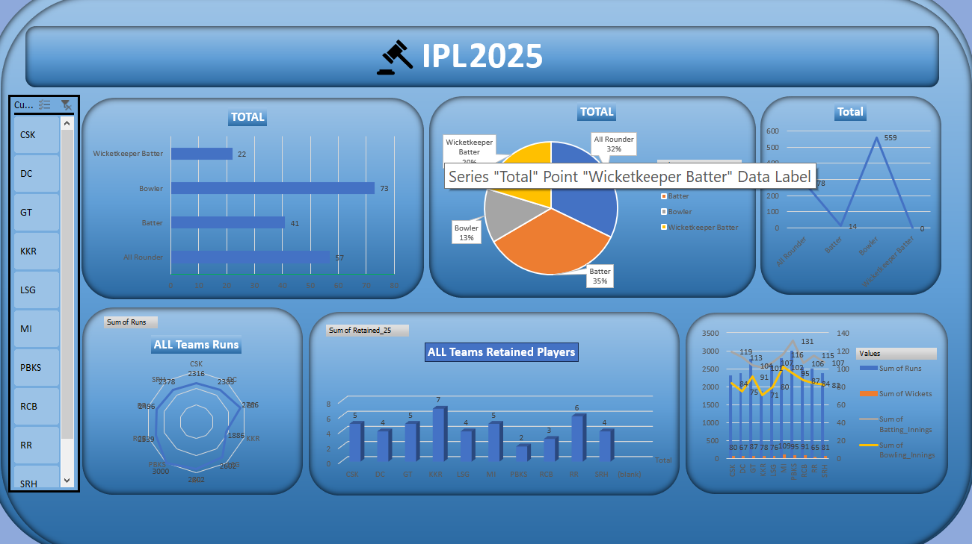

6. Insights and Findings
Key insights obtained from the IPL 2025 dashboard include:
• Top batsmen scored consistently across multiple matches with high strike rates.
• Certain teams maintained dominant performances throughout the season.
• The dashboard revealed patterns in player performance based on venue and match type.
• Performance consistency helped identify emerging talents in IPL 2025.

7. Conclusion
The IPL 2025 Excel Dashboard successfully visualizes key cricket performance data. It simplifies data analysis for both fans and analysts by presenting real-time trends and season highlights in a single view. Future improvements may include automation using Power Query and integration with Power BI for enhanced interactivity.

8. References
• Microsoft Excel Documentation
• IPL Official Statistics 2025 (https://www.iplt20.com)
• Data Analysis and Visualization Tutorials (MS Excel)

